

**S.Y.B.Sc**

**Computer Science**

**2019 – 2020**

**This is to certify that PRASHANT SINGH of S.Y.B.Sc Roll No. 70 has successfully completed the practical of Paper – VII (sem – III)** **Skill Enhancement: Web Programming during the Academic Year 2019-2020 as specified by the MUMBAI UNIVERSITY.**

**Prof. (Mrs.) Priyanka Gavhane Prof. (Mrs.) Anita Gaikwad.**

**Professor-In-charge In-charge**

**Dept. of Computer Science Dept. of Computer Science**

**Name : PRASHANT SINGH Subject: WEB TECHNOLOGY**

**Class: SYBSC(COMPUTER SCIENCE) Exam Seat no: 70**

**Academic Year : 2019-2020**

|  |  |  |  |  |
| --- | --- | --- | --- | --- |
|  |  | **INDEX** |  |  |
| **No** | **Date** | **TITLE** | **Page**  **No** | **SIGN** |
| 1 | 26/06/2019 | Design a webpage that makes use of  1.Document Structure Tags  2. Various Text Formatting Tags  3. List Tags  4. Image and Image map |  |  |
| 2 | 03/07/2019 | Design a Web page that makes use of   1. Table Tags 2. Form Tags 3. Navigation across multiple pages 4. Embedded Multimedia elements |  |  |
| 3 | 3/07/2019 | Design a webpage that make use of Cascading Style Sheets with   * CSS properties to change the background of a Page. * CSS properties to change Fonts and Text Styles * CSS properties for postioning an element. |  |  |
| 4 | 10/07/2018 | Write a Java Script Program for   * Performing various mathematical operations such as calculating factorial/finding Fibonnacci Series/Displaying Prime Numbers in a given range / Calculating reverse of a number * Validating the various form elements |  |  |
| 5 | 24/07/2019 | Write a Java Script Program for   * Demonstrating String,Math object. * Demonstrating different Javascript Objects such as Navigator, History ,Location. * Storing and Retrieving Cookies. |  |  |
| 6 | 31/07/2019 | Create a XML file internal dtd and css. |  |  |
| 7 | 7/08/2019 | Design a web page to handle asynchronous request using AJAX on mouse over. |  |  |
| 8 | 21/08/2019 | Write a php script for retrieving form data. |  |  |
| 9 | 21/08/2019 | Design a Web page with some jQuery animation effect. |  |  |

**Practical 1**

**Aim:** Design a webpage that makes use of

1.Document Structure Tags

2. Various Text Formatting Tags

3. List Tags

4. Image and Image map

**Program:**

**Q1. Demonstrate Document Structure Tags of HTML.**

**Source Code:**

<!DOCTYPE html>

<html>

<head><title> Document Structure</title>

</head>

<body>

<h1> Document Structure </h1>

<p>This is my first page in html</p>

<p>This is an example of a paragraph</p>

</body>

</html>

**Output:**

Document Structure

This is my first page in html

This is an example of a paragraph

**Q2. Design a webpage that makes use of Various Text Formatting Tags**

**Source Code:**

<!DOCTYPE html>

<html>

<head><title> Text Formatting Tags</title>

</head>

<body>

<h1> Formatting Tags</h1>

<p><b> This text is bold</b></p>

<p><i> This text is italic</i></p>

<p>This is <sub> subscript</sub> and <sup> superscript</sup></p>

<p><strong>This text is strong</strong></p>

<p><em>This text is emphasized. </em></p>

<h2>HTML <small>Small</small> Formatting</h2>

<h2>HTML <mark>Marked</mark> Formatting</h2>

<p> The del element represents deleted (removed)text.</p>

<p> My favorite color is <del>blue</del> red.</p>

<p> My favorite <ins>color</ins> is red.</p>

</body>

</html>

**Output:**

Formatting Tags

This text is bold

This text is italic

This is subscript and superscript

This text is strong

This text is emphasized.

HTML Small Formatting

HTML Marked Formatting

The del element represents deleted (removed)text.

My favorite color is blue red.

My favorite color is red.

**Q3. Design a webpage that makes use of List Tags.**

**Source Code:**

<!DOCTYPE html>

<html>

<head><title> List Tags</title>

</head>

<body>

<h2>An Unordered HTML List</h2>

<ul>

<li>ARTS</li>

<li>COMMERCE</li>

<li>SCIENCE</li>

</ul>

<h2>An Ordered HTML List</h2>

<ol>

<li>F.Y.CS</li>

<li>S.Y.CS</li>

<li>T.Y.CS</li>

</ol>

</body>

</html>

**Output:**

An Unordered HTML List

• ARTS

• COMMERCE

• SCIENCE

An Ordered HTML List

1. F.Y.CS

2. S.Y.CS

3. T.Y.CS

**Q4. Design a webpage that makes use of Image and Image map.**

**Source Code:**

<!DOCTYPE html>

<html>

<head><title> Image Map </title>

</head>

<body>

<h2 align="center"><font color="red"><strong>web Page With Image Maps</strong></font></h2>

<img src="imagem1.gif" align="center" alt="Image of Image Map" usemap="#imagemap">

<map name="imagemap">

<area shape="rect" coords="52,86,163,180" href="Practical1a.html" >

<area shape="poly" coords="368,108,419,87,472,140,472,170,401,175" href="practical1b.html">

<area shape="circle" coords="270,134,20" href="practical1c.html">

</map>

</body>

</html>

**Output:**

web Page With Image Maps

Image of Image Ma

**Practical 2**

**Aim:** Design a Web page that makes use of

1. Table Tags

2. Form Tags

3. Navigation across multiple pages

4. Embedded Multimedia elements

**Program:**

**Q1.Demonstrate Table Tags of HTML**.

**Source Code:**

<!DOCTYPE html>

<html>

<head><title> Complex Table </title>

</head>

<body>

<table border="5px">

<caption>A complex table</caption>

<thead>

<tr>

<th colspan="3">Invoice #123456789</th>

<th>14 January 2025

</tr>

<tr>

<td colspan="2">

<strong>Pay to:</strong>

<br> Acme Billing Co.<br> 123 Main St.<br> Cityville, NA 12345 </td>

<td colspan="2">

<strong>Customer:</strong>

<br> John Smith<br> 321 Willow Way<br> Southeast Northwestershire, MA 54321 </td>

</tr>

</thead>

<tbody>

<tr>

<th>Name / Description</th>

<th>Qty.</th>

<th>@</th>

<th>Cost</th>

</tr>

<tr>

<td>Paperclips</td>

<td>1000</td>

<td>0.01</td>

<td>10.00</td>

</tr>

<tr>

<td>Staples (box)</td>

<td>100</td>

<td>1.00</td>

<td>100.00</td>

</tr>

</tbody>

<tfoot>

<tr>

<th colspan="3">Subtotal</th>

<td> 110.00</td>

</tr>

<tr>

<th colspan="2">Tax</th>

<td> 8% </td>

<td>8.80</td>

</tr>

<tr>

<th colspan="3">Grand Total</th>

<td>$ 118.80</td>

</tr>

</tfoot>

</table>

</body>

</html>

**Output:**

|  |  |  |  |
| --- | --- | --- | --- |
| **Invoice #123456789** | | | **14 January 2025** |
| **Pay to:**  Acme Billing Co. 123 Main St. Cityville, NA 12345 | | **Customer:**  John Smith 321 Willow Way Southeast Northwestershire, MA 54321 | |
| **Name / Description** | **Qty.** | **@** | **Cost** |
| Paperclips | 1000 | 0.01 | 10.00 |
| Staples (box) | 100 | 1.00 | 100.00 |
| **Subtotal** | | | 110.00 |
| **Tax** | | 8% | 8.80 |
| **Grand Total** | | | $ 118.80 |

**Q2. Design a Web Page that makes use of Form Tags**.

**Source Code:**

<!DOCTYPE HTML>

<html>

<head>

<title>Form Page: Sampleform</title>

</head>

<body>

<h1>sample Form Page</h1>

<form id="sampleform" method="post" action="welcome.html">

<p>Name: <input type="text" name="Name"/>

</p>

<p>Email: <input type="text" name="Email" />

</p>

<p>

Gender:<input type="radio" name="r1" /> Male

<input type="radio" name="r1" /> Female

</p>

<p>

Hobbies:<input type="checkbox" name="hobbies1" value="on">Dancing

<input type="checkbox" name="hobbies1" value="on">Reading

<input type="checkbox" name="hobbies1" value="on">Swimming

<input type="checkbox" name="hobbies1" value="on">Singing

</p>

<p>

<input type="submit" name="submit" value="Submit" />

</p>

</form>

</body>

</html>

**Output:**

# sample Form Page

Top of Form

Name: 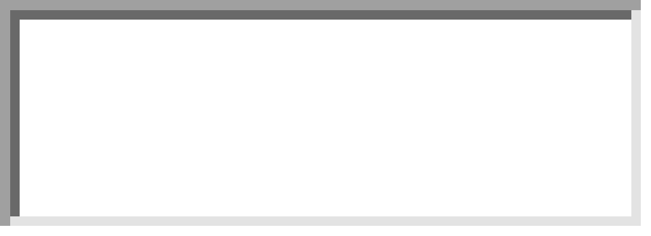

Email: 

Gender: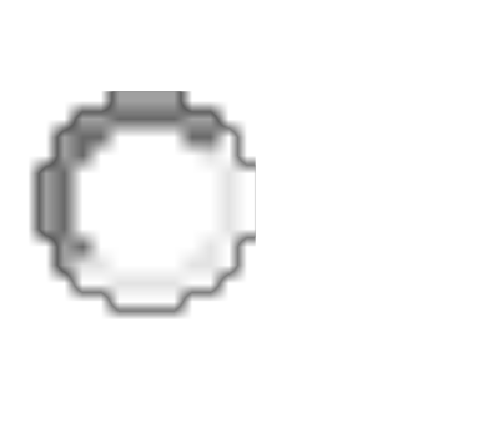 Male Female

Hobbies:Dancing Reading Swimming Singing

**Q3. Design a Web page that makes use of Navigation across multiple pages**.

**Source Code:**

<!DOCTYPE HTML>

<html>

<head><title>Navigation of Multiple Pages</title></head>

<body>

<div align="center">

<a href="index.html">Index</a>|

<a href="nature.html">Nature</a>|

<a href="history.html">History</a>|

<a href="art.html">Art</a>

</div>

</body>

</html>

**Q4. Design a Web page that makes use of Embedded multimedia elements.**

**Source code:**

<html>

<head>

<title>Embeding Videos on a web page</title>

</head>

<body>

video play

<video width="320" height="240" autoplay>

<source scr="Wildlife.wmv" type="vdeo/mp4">

</video>

</body>

</html>

**Output:**

Index| Nature| History| Art

**Practical 3**

**Aim:** Design a webpage that make use of Cascading Style Sheets with

* CSS properties to change the background of a Page.
* CSS properties to change Fonts and Text Styles
* CSS properties for postioning an element.

**Program:**

**Q1.Demonstrate** **CSS properties to change the background of a Page.**

**Source Code:**

<html>

<head><title>CSS Properties to change Fonts and Text Styles</title>

<style type="text/css">

h1{

background-color: green;

}

p{

background-color: yellow;

}

</style>

</head>

<body>

<h1>CSS Background-color example!</h1>

<p>This paragraph will have a different background colour</p>

</body>

</html>

**Output:**

# CSS Background-color example!

This paragraph will have a different background colour

**Q2. Design a webpage that make use of Cascading Style Sheets with CSS properties to change Fonts and Text Styles**

**Source Code:**

<html>

<head><title>CSS Properties to change Fonts and Text Styles</title>

<style type="text/css">

p.normal{

font-family:"Times New Roman";

font-style: normal;

}

p.italic{

font-family: Arial;

font-style: italic;

}

p.oblique{

font-family: Arial;

font-style: oblique;

}

</style>

</head>

<body>

<p class="normal">Paragraph in normal form.</p>

<p class="italic"> Paragraph in Italic style.</p>

<p class="oblique"> Paragraph in oblique style.</p>

</body>

</html>

**Output:**

Paragraph in normal form.

*Paragraph in Italic style.*

Paragraph in oblique style.

**Q3. Design a webpage that make use of Cascading Style Sheets with CSS properties for positioning an element**

**Source Code:**

<html>

<head><title>CSS Properties for positioning an element</title>

<style type="text/css">

h2{

position: static;

border: 3px solid #73AD21;

}

p.relative{

position: relative;

left: 30px;

border: 3px solid #73AD21;

}

</style>

</head>

<body>

<h2> Position: static</h2>

<p class="relative">This paragraph will be positioned relatively</p>

</body>

</html>

**Output**:

## Position: static

This paragraph will be positioned relatively

**Practical 4**

**Aim:** Write a Java Script Program for

* Performing various mathematical operations such as calculating factorial/finding Fibonnacci Series/Displaying Prime Numbers in a given range / Calculating reverse of a number
* Validating the various form elements

**Source** **Code**:

<!doctype html>

<html>

<head>

<script>

function show(){

var i, no, fact;

fact=1;

no=Number(document.getElementById("num").value);

for(i=1; i<=no; i++)

{

fact= fact*i;

}

document.getElementById("answer").value= fact;

}

</script>

</head>

<body>

Enter Num: <input id="num">

<button onclick="show()">Factorial</button>

<input id="answer">

</body>

</html>

**Output:**

Enter Num: 

**Q2. Write a Java Script Program for calculating Fibonacci Series.**

**Source Code:**

<html>

<head><title>Fibonacci Series</title></head>

<body>

<script type="text/javascript">

<!—

var var1 = 0;

var var2 = 1;

var var3;

var num = prompt("Enter the limit to generate fibonacci no",0);

document.write(var1+"<br />");

document.write(var2+"<br />");

for(var i=3; i <= num;i++)

{

var3 = var1 + var2;

var1 = var2;

var2 = var3;

document.write(var3+"<br />");

}

// -->

</script>

</body>

</html>

**Output:**

|  |  |  |  |
| --- | --- | --- | --- |
| Enter the limit to generate fibonacci no   |  | | --- | | 5 |      |  |  | | --- | --- | | OK | Cancel | |

0  
1  
1  
2  
3

**Q3. Write a Java Script Program for Displaying Prime number in a given range.**

**Source Code:**

<html>

<head>

<title>JavaScript to print prime numbers!</title>

<meta charset="UTF-8">

<meta name="viewport" content="width=device-width, initial-scale=1.0">

<script>

function printPrime() {

var i = 0;

var j = 0;

limit = document.getElementById('limit').value;

//loop till i equals to $limit

for (i = 1; i <= limit; i++) {

c = 0;

for (j = 1; j <= i; j++) {

// % modules will give the reminder value, so if the reminder is 0 then it is divisible

if (i % j == 0) {

//increment the value of c

c++;

}

}

//if the value of c is 2 then it is a prime number

//because a prime number should be exactly divisible by 2 times only (itself and 1)

if (c == 2) {

document.getElementById("result").insertAdjacentHTML( i + '<br>');

}

}

}

</script>

</head>

<body>

<h2>JavaScript to print Prime numbers!</h2>

Enter the limit: <input type="number" name="limit" id="limit" min="0" style="width: 100px;" />&nbsp;<input type="submit" value="Print Prime Numbers" onclick="printPrime()" name="print" />

<div id="result"></div>

</body>

</html>

**Q4. Write a Java Script program for calculating Reverse of a number.**

**Source Code:**

<!doctype html>

<html>

<head>

<script>

function palin()

{

var a,no,b,temp=0;

no=Number(document.getElementById("no_input").value);

b=no;

while(no>0)

{

a=no%10;

no=parseInt(no/10);

temp=temp*10+a;

}

alert(temp);

}

</script>

</head>

<body>

Enter any Number: <input id="no_input">

<button onclick="palin()">Check</button></br></br>

</body>

</html>

**Q5. Write a Java Script program for Validating the various form elements.**

**Source Code:**

<html>

<head>

<script>

function GEEKFORGEEKS()

{

var name = document.forms["RegForm"]["Name"];

var email = document.forms["RegForm"]["EMail"];

var phone = document.forms["RegForm"]["Telephone"];

var what = document.forms["RegForm"]["Subject"];

var password = document.forms["RegForm"]["Password"];

var address = document.forms["RegForm"]["Address"];

if (name.value == "")

{

window.alert("Please enter your name.");

name.focus();

return false;

}

if (address.value == "")

{

window.alert("Please enter your address.");

name.focus();

return false;

}

if (email.value == "")

{

window.alert("Please enter a valid e-mail address.")

email.focus();

return false;

}

if (email.value.indexOf("@", 0) < 0)

{

window.alert("Please enter a valid e-mail address.");

email.focus();

return false;

}

if (email.value.indexOf(".", 0) < 0)

{

window.alert("Please enter a valid e-mail address.");

email.focus();

return false;

}

if (phone.value == "")

{

window.alert("Please enter your telephone number.");

phone.focus();

return false;

}

if (password.value == "")

{

window.alert("Please enter your password");

password.focus();

return flase;

}

if (what.selectedIndex < 1)

{

alert("Please enter your course.");

what.focus();

return false;

}

return true;

}</script>

<style>

GEEKFORGEEKS {

margin-left: 70px;

font-weight: bold ;

float: left;

clear: left;

width: 100px;

text-align: left;

margin-right: 10px;

font-family:sans-serif,bold, Arial, Helvetica;

font-size:14px;

}

div {

box-sizing: border-box;

width: 100%;

border: 100px solid black;

float: left;

align-content: center;

align-items: center;

}

form {

margin: 0 auto;

width: 600px;

}</style></head>

<body>

<h1 style="text-align: center"> REGISTRATION FORM </h1>

<form name="RegForm" action="/submit.php" onsubmit="return GEEKFORGEEKS()" method="post">

<p>Name: <input type="text" size=65 name="Name"> </p><br>

<p> Address: <input type="text" size=65 name="Address"> </p><br>

<p>E-mail Address: <input type="text" size=65 name="EMail"> </p><br>

<p>Password: <input type="text" size=65 name="Password"> </p><br>

<p>Telephone: <input type="text" size=65 name="Telephone"> </p><br>

<p>SELECT YOUR COURSE

<select type="text" value="" name="Subject">

<option>BTECH</option>

<option>BBA</option>

<option>BCA</option>

<option>B.COM</option>

<option>GEEKFORGEEKS</option>

</select></p><br><br>

<p>Comments: <textarea cols="55" name="Comment"> </textarea></p>

<p><input type="submit" value="send" name="Submit">

<input type="reset" value="Reset" name="Reset">

</p>

</form>

</body>

</html>

**OUTPUT:**

# REGISTRATION FORM

Top of Form

Name: 

Address: 

E-mail Address: 

Password: 

Telephone: 

SELECT YOUR COURSE

Bottom of Form

Comments: 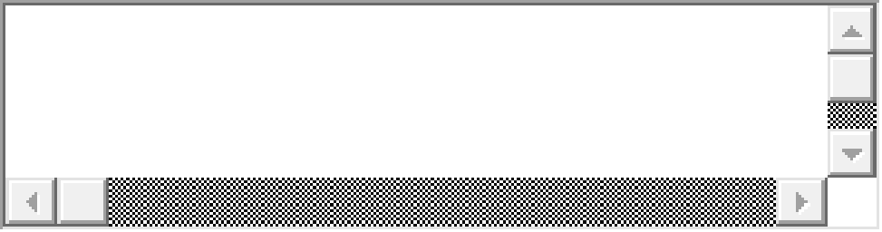

**Practical 5**

**Aim:** Write a Java Script Program for

* Demonstrating String,Math object.
* Demonstrating different Javascript Objects such as Navigator, History ,Location.
* Storing and Retrieving Cookies.

**Source Code:**

<html>

<head><title>String Demonstration</title></head>

<body>

<script>

var str1= "Hey diddle, the cat and the fiddle, The cow jumped over the moon.";

var str2= "The little dog laughed to see such fun, And the dish ran away with the spoon!";

document.write(str1 + "<br>" + str2 + "<br>");

var sln = str1.length;

document.write("<br>"+"Length of string is "+ sln + "<br>");

var x = "It\'s alright";

var y = "We are the so-called \"Vikings\" from the north";

document.write("<br>"+x+"<br>");

document.write("<br>"+y+"<br>");

</script>

</body>

</html>

**OUTPUT:**

Hey diddle, the cat and the fiddle, The cow jumped over the moon.  
The little dog laughed to see such fun, And the dish ran away with the spoon!  
  
Length of string is 72  
  
It's alright  
  
We are the so-called "Vikings" from the north

**Q2. Write a Java Script Program for Demonstrating Math object.**

**Source Code:**

<html>

<head><title>Math Demonstration</title></head>

<body>

<script type="text/javascript">

document.write("PI="+Math.PI+"<br>");

document.write("Random Number="+Math.random(49.657)+"<br>");

document.write("Rounding="+Math.round(6.433)+"<br>");

document.write("Pow="+Math.pow(10,3)+"<br>");

document.write("Square Root="+Math.sqrt(64)+"<br>");

document.write("Absolute="+Math.abs(-67.7)+"<br>");

document.write("Ceil="+Math.ceil(6.4)+"<br>");

document.write("Floor="+Math.floor(4.7)+"<br>");

document.write("sin="+Math.sin(90*Math.PI/180)+"<br>");

document.write("cos="+Math.cos(90*Math.PI/180)+"<br>");

document.write("finding max="+Math.max(0,150,30,20,-8,-200)+"<br>");

document.write("finding min="+Math.min(0,150,30,20,-8,-200)+"<br>");

</script>

</body>

</html>

**OUTPUT:**

PI=3.141592653589793  
Random Number=0.37051632654597333  
Rounding=6  
Pow=1000  
Square Root=8  
Absolute=67.7  
Ceil=7  
Floor=4  
sin=1  
cos=6.123233995736766e-17  
finding max=150  
finding min=-200

**Q3. Write a Java Script program for Demonstrating Navigator object.**

**Source Code:**

<html>

<body>

<h2>Java Script Navigator Object</h2>

<script>

document.write("<br/>navigator.appCodeName: "+navigator.appCodeName);

document.write("<br/>navigator.cookieEnabled: "+navigator.cookieEnabled);

document.write("<br/>navigator.userAgent: "+navigator.userAgent);

document.write("<br/>navigator.appName: "+navigator.appName);

document.write("<br/>navigator.appVersion: "+navigator.appVersion);

document.write("<br/>navigator.platform: "+navigator.platform);

document.write("<br/>navigator.language: "+navigator.language);

document.write("<br/>navigator.onLine: "+navigator.onLine);

</script>

</body>

</html>

**OUTPUT:**

## Java Script Navigator Object

navigator.appCodeName: Mozilla  
navigator.cookieEnabled: true  
navigator.userAgent: Mozilla/5.0 (Windows NT 6.1; Win64; x64; rv:62.0) Gecko/20100101 Firefox/62.0  
navigator.appName: Netscape  
navigator.appVersion: 5.0 (Windows)  
navigator.platform: Win64  
navigator.language: en-US  
navigator.onLine: true

**Q4. Write a Java Script program for Demonstrating History object.**

**Source Code:**

<html>

<head>

<script>

function goBack()

{

window.history.back()

}

</script>

</head>

<body>

<input type="button" value="Back" onclick="goBack()">

</body>

</html>

**OUTPUT:**

Back

**Q5. Write a Java Script program for Demonstrating Location object.**

**Source Code:**

<html>

<body>

<input type="button" value="Replace URL" onclick="myFun()"/>

<script type="text/javascript">

function myFun()

{

location.replace("http://www.google.com")

}

</script>

</body>

</html>

**OUTPUT:**

|  |
| --- |
| Replace URL |

**Q6. Write a Java Script program for storing cookies.**

**Source Code:**

<html>

<head>

<script type = "text/javascript">

<!--

function WriteCookie()

{

if( document.myform.customer.value == "" ){

alert("Enter some value!");

return;

}

cookievalue= escape(document.myform.customer.value) + ";";

document.cookie="name=" + cookievalue;

document.write ("Setting Cookies : " + "name=" + cookievalue );

}

//-->

</script>

</head>

<body>

<form name="myform" action="">

Enter name: <input type="text" name="customer"/>

<input type="button" value="Set Cookie" onclick="WriteCookie();"/>

</form>

</body>

</html>

**OUTPUT:**

Enter name: 

**Q7. Write a java Script program for storing cookie with expiry date.**

**Source Code:**

<html>

<head>

<script type="text/javascript">

<!--

function WriteCookie()

{

var now = new Date();

now.setMonth( now.getMonth() + 1 );

cookievalue = escape(document.myform.customer.value) + ";"

document.cookie="name=" + cookievalue;

document.cookie = "expires=" + now.toUTCString() + ";"

document.write ("Setting Cookies : " + "name=" + cookievalue );

}

//-->

</script>

</head>

<body>

<form name="myform" action="">

Enter name: <input type="text" name="customer"/>

<input type="button" value="Set Cookie" onclick="WriteCookie()"/>

</form>

</body>

</html>

**OUTPUT:**

Enter name: 

**Q8. Write a Java Script program for Reading cookie.**

**Source Code:**

<html>

<head>

<script type="text/javascript">

<!--

function ReadCookie()

{

var allcookies = document.cookie;

document.write ("All Cookies : " + allcookies );

// Get all the cookies pairs in an array

cookiearray = allcookies.split(';');

// Now take key value pair out of this array

for(var i=0; i<cookiearray.length; i++){

name = cookiearray[i].split('=')[0];

value = cookiearray[i].split('=')[1];

document.write ("Key is : " + name + " and Value is : " + value);

}

}

//-->

</script>

</head>

<body>

<form name="myform" action="">

<p> click the following button and see the result:</p>

<input type="button" value="Get Cookie" onclick="ReadCookie()"/>

</form>

</body>

</html>

**OUTPUT:**

click the following button and see the result:

|  |
| --- |
| Get cookie |

**Practical 6**

**Aim:** Create a XML file internal dtd and css.

**Source** **Code**:

<?xml version="1.0"?>

<?xml-stylesheet type="text/css" href="cssemployee.css"?>

<!DOCTYPE employee [

<!ELEMENT employee (firstname,lastname,email)>

<!ELEMENT firstname (#PCDATA)>

<!ELEMENT lastname (#PCDATA)>

<!ELEMENT email (#PCDATA)>

]>

<employee>

<firstname>vimal</firstname>

<lastname>jaiswal</lastname>

<email>vimal@javatpoint.com</email>

</employee>

Css: csseployee.css

employee

{

background-color: pink;

}

firstname,lastname,email

{

font-size:25px;

display:block;

color: blue;

margin-left: 50px;

}

**Output**:

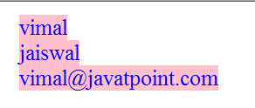

**Q2. Create a XML file with external dtd and display it using XSL.**

**Source Code:**

<?xml version = "1.0"?>

<!--student4.xml for XSLT-->

<!DOCTYPE students SYSTEM "students.dtd">

<?xml-stylesheet type = "text/xsl" href = "students.xsl"?>

<students>

<student>

<name>

<firstname> James </firstname>

<lastname> Smith </lastname>

</name>

<address>

<street> 101 South Street</street>

<city> Halifax </city>

<email> james@dal.ca </email>

<phone> 4940001 </phone>

</address>

</student>

<student>

<name>

<firstname> Tom </firstname>

<lastname> White </lastname>

</name>

<address>

<street> 202 Victoria Road </street>

<city> Dartmouth </city>

<email> tom@dal.ca</email>

<phone> 4940002 </phone>

</address>

</student>

</students>

Students.dtd:

<?xml version = "1.0"?>

<!--students.dtd-a document type definition for the students.xml-->

<!ELEMENT students (student+)>

<!ELEMENT student (name,address)>

<!ELEMENT name (firstname,lastname)>

<!ELEMENT firstname (#PCDATA)>

<!ELEMENT lastname (#PCDATA)>

<!ELEMENT address (street,city,email,phone)>

<!ELEMENT street (#PCDATA)>

<!ELEMENT city (#PCDATA)>

<!ELEMENT email (#PCDATA)>

<!ELEMENT lastname (#PCDATA)>

Students.xsl:

<?xml version ="1.0"?>

<!--students.xsl-->

<xsl:stylesheet version = "1.0"

xmlns:xsl="http://www.w3.org/1999/XSL/Transform"

xmlns="http://www.w3.org/TR/xhtml1/strict">

<xsl:template match = "/">

<h2> Student Record </h2>

<xsl:for-each select="students/student">

<br/>

<span style="font-weight:bold;color:red"> FirstName: </span>

<xsl:value-of select="name/firstname" />

<span style="font-weight:bold;color:red"> LastName: </span>

<xsl:value-of select="name/lastname" /> <br/>

<span style="font-weight:bold;color:green"> Street: </span>

<xsl:value-of select="address/street" /> <br/>

<span style="font-weight:bold;color:green"> City: </span>

<xsl:value-of select="address/city" /> <br/>

<span style="font-weight:bold;color:blue"> Email: </span>

<xsl:value-of select="address/email" /> <br/>

<span style="font-weight:bold;color:green"> Phone: </span>

<xsl:value-of select="address/phone" /> <br/>

</xsl:for-each>

</xsl:template>

</xsl:stylesheet>

**Output:**

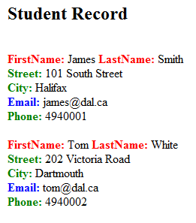

**Practical 7**

**Aim**: Design a web page to handle asynchronous request using AJAX on mouse over.

**Source** **Code**:

<html>

<body>

<h1>The XMLHttpRequestAsynchronous Reques </h1>

<button type="button" onmouseover="showFile()" > Show text file content</button>

<script>

function showFile()

{

var xhttp = new XMLHttpRequest();

xhttp.onreadystatechange = function(){

if(this.readyState==4 && this.status == 200)

{

document.write(this.responseText);

}

}

xhttp.open("GET","Myfile.txt",true);

xhttp.send();

}

</script>

</body>

</html>

**Q2. Design a web page to handle asynchronous request using AJAX on button click.**

**Source Code:**

<!DOCTYPE html>

<html>

<body>

<h2>The XMLHttpRequest Object</h2>

<button type="button" onclick="loadDoc()">Request data</button>

<p id="demo"></p>

<script>

function loadDoc() {

var xhttp = new XMLHttpRequest();

xhttp.onreadystatechange = function() {

if (this.readyState == 4 && this.status == 200) {

document.getElementById("demo").innerHTML = this.responseText;

}

};

xhttp.open("GET", "Practical1a.html", true);

xhttp.send();

}

</script>

</body>

</html>

**Practical 8**

**Aim:** Write a php script for retrieving form data.

**Source** **Code**:

<html>  
<body>  
<form action="welcome.php" method="post">  
Name: <input type="text" name="name"><br>  
E-mail: <input type="text" name="email"><br>  
<input type="submit">  
</form>  
</body>  
</html>

Welcome.php:

<html>  
<body>  
  
Welcome <?php echo $_POST["name"]; ?><br>  
Your email address is: <?php echo $_POST["email"]; ?>  
  
</body>  
</html>

**Output:**

Welcome John  
Your email address is [john.doe@example.com](mailto:john.doe@example.com)

**Q2. Write a php program for calculating factorial of a number.**

**Source Code:**

<?php

$num = 4;

$factorial = 1;

for ($x=$num; $x>=1; $x--)

{

  $factorial = $factorial * $x;

}

echo "Factorial of $num is $factorial";

?>

**Output:**

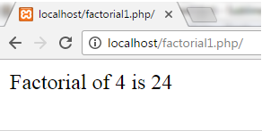

**Q3. Write a php program for finding Fibonacci series of a number.**

**Source Code:**

<?php

$num = 0;

$n1 = 0;

$n2 = 1;

echo "<h3>Fibonacci series for first 12 numbers: </h3>";

echo "\n";

echo $n1.' '.$n2.' ';

**while** ($num < 10 )

{

    $n3 = $n2 + $n1;

    echo $n3.' ';

    $n1 = $n2;

    $n2 = $n3;

    $num = $num + 1;

?>

**Output:**

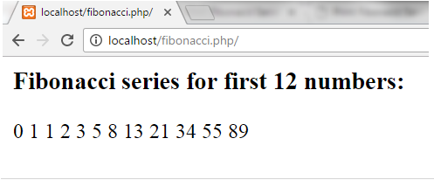

**Q4. Write a php program for displaying prime number.**

**Source Code:**

<?php

$count = 0;

$num = 2;

**while** ($count < 15 )

{

$div_count=0;

**for** ( $i=1; $i<=$num; $i++)

{

**if** (($num%$i)==0)

{

$div_count++;

}

}

**if** ($div_count<3)

{

echo $num." , ";

$count=$count+1;

}

$num=$num+1;

}

?>

**Output:**

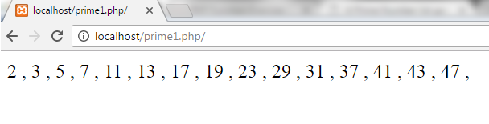

**Q5. Write a php program for displaying Reverse of a number.**

**Source Code:**

<?php

$num = 23456;

$revnum = 0;

**while** ($num > 1)

{

$rem = $num % 10;

$revnum = ($revnum * 10) + $rem;

$num = ($num / 10);

}

echo "Reverse number of 23456 is: $revnum";

?>

**Output:**

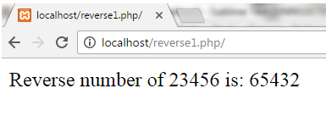

**Practical 9**

**Aim**: Write a PHP Script for Storing records in a data base.

**Source** **Code**:

<!DOCTYPE html>

<html>

<head>

<title>PHP insertion</title>

<link href="css/insert.css" rel="stylesheet">

</head>

<body>

<div class="maindiv">

<!--HTML Form -->

<div class="form_div">

<div class="title">

<h2>Insert Data In Database Using PHP.</h2>

</div>

<form action="insert.php" method="post">

<!-- Method can be set as POST for hiding values in URL-->

<h2>Form</h2>

<label>Name:</label>

<input class="input" name="name" type="text" value="">

<label>Email:</label>

<input class="input" name="email" type="text" value="">

<label>Contact:</label>

<input class="input" name="contact" type="text" value="">

<label>Address:</label>

<textarea cols="25" name="address" rows="5"></textarea><br>

<input class="submit" name="submit" type="submit" value="Insert">

</form>

</div>

</div>

</body>

</html>

**Php file:**

<?php

$connection = mysql_connect("localhost", "root", ""); // Establishing Connection with Server

$db = mysql_select_db("colleges", $connection); // Selecting Database from Server

if(isset($_POST['submit'])){ // Fetching variables of the form which travels in URL

$name = $_POST['name'];

$email = $_POST['email'];

$contact = $_POST['contact'];

$address = $_POST['address'];

if($name !=''||$email !=''){

//Insert Query of SQL

$query = mysql_query("insert into students(student_name, student_email, student_contact, student_address) values ('$name', '$email', '$contact', '$address')");

echo "<br/><br/><span>Data Inserted successfully...!!</span>";

}

else{

echo "<p>Insertion Failed <br/> Some Fields are Blank....!!</p>";

}

}

mysql_close($connection); // Closing Connection with Server

?>

**Output:**

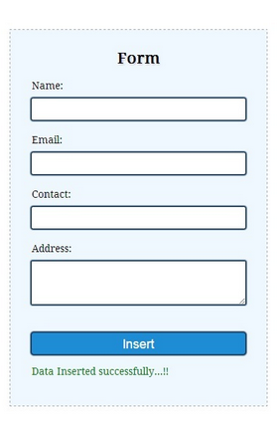

**Q2. Write a PHP program for fetching data using php.**

**Source Code:**

<!DOCTYPE html>  
<html>  
<body>  
  
<?php  
$servername = "localhost";  
$username = "username";  
$password = "password";  
$dbname = "myDB";  
  
// Create connection  
$conn = new mysqli($servername, $username, $password, $dbname);  
// Check connection  
if ($conn->connect_error) {  
    die("Connection failed: " . $conn->connect_error);  
}   
  
$sql = "SELECT id, firstname, lastname FROM MyGuests";  
$result = $conn->query($sql);  
  
if ($result->num_rows > 0) {  
    // output data of each row  
    while($row = $result->fetch_assoc()) {  
        echo "<br> id: ". $row["id"]. " - Name: ". $row["firstname"]. " " . $row["lastname"] . "<br>";  
    }  
} else {  
    echo "0 results";  
}  
  
$conn->close();  
?>   
  
</body>  
</html>

**Output**:

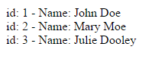

**Practical 10**

**Aim:** Design a Web page with some jQuery animation effect.

**Source Code:**

<!DOCTYPE html>

<html>

<head>

<script src="https://ajax.googleapis.com/ajax/libs/jquery/3.3.1/jquery.min.js"></script>

<script>

$(document).ready(function(){

$("button").click(function(){

$("div").animate({

left: '250px',

height: '+=150px',

width: '+=150px'

});

});

});

</script>

</head>

<body>

<button>Start Animation</button>

<p>By default, all HTML elements have a static position, and cannot be moved. To manipulate the position, remember to first set the CSS position property of the element to relative, fixed, or absolute!</p>

<div style="background:#98bf21;height:100px;width:100px;position:absolute;"></div>

</body>

</html>

**Output:**

